TASK 1: Create Windows VM (B2s) and Connect Using RDP

Objective
To create a Windows Virtual Machine in Azure, assign a Public IP address, and connect to it using Remote Desktop Protocol (RDP).

Virtual Machine (VM) Theory
A Virtual Machine (VM) is a software-based computer that runs on physical hardware provided by a cloud service provider. In Microsoft Azure, Virtual Machines are an Infrastructure as a Service (IaaS) offering that allows users to deploy and manage Windows or Linux servers on demand.
Azure Virtual Machines provide scalable compute resources without requiring organizations to purchase and maintain physical servers. Each VM can be configured with different CPU, memory, storage, and networking options based on business requirements.
In this task, a Windows Virtual Machine was deployed using the Standard B2s size. The VM was connected to a Virtual Network (VNet), assigned a Public IP address for internet accessibility, protected using a Network Security Group (NSG), and accessed remotely using the Remote Desktop Protocol (RDP) over port 3389.

Components Used
- Virtual Machine (VM): Provides compute resources.
- Virtual Network (VNet): Enables network communication.
- Subnet: Logical segmentation within a VNet.
- Public IP Address: Allows external connectivity.
- Network Security Group (NSG): Controls inbound and outbound traffic.
- Managed Disk: Stores the operating system and data.
- RDP (3389): Used for remote administration of Windows VMs.

Step 1: Open Virtual Machines Service
Virtual Machines is an Azure compute service used to deploy and manage virtual servers in the cloud.
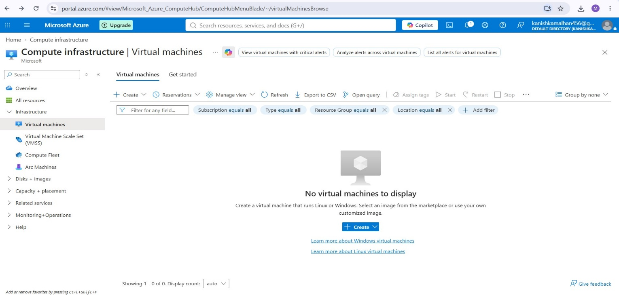

Step 2: Start Virtual Machine Creation
Click Create → Azure Virtual Machine to launch the VM deployment wizard.
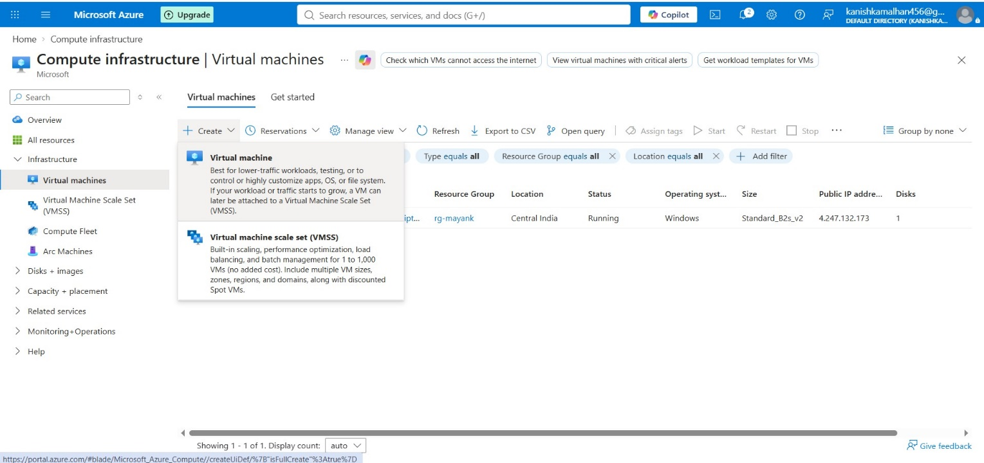

Step 3: Configure Basic VM Details
Provide Resource Group, VM Name, Region, Operating System, and other basic configuration details required for VM deployment.
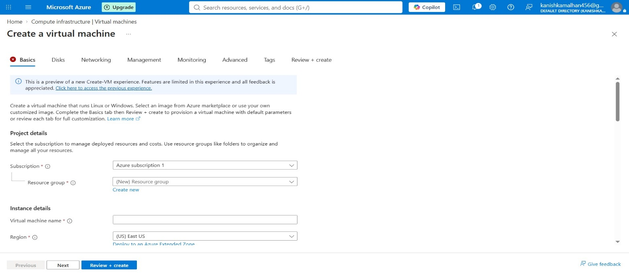

Step 4: Configure Resource Group and Region
Select the Resource Group rg-mayank, provide the VM name, and choose the deployment region.
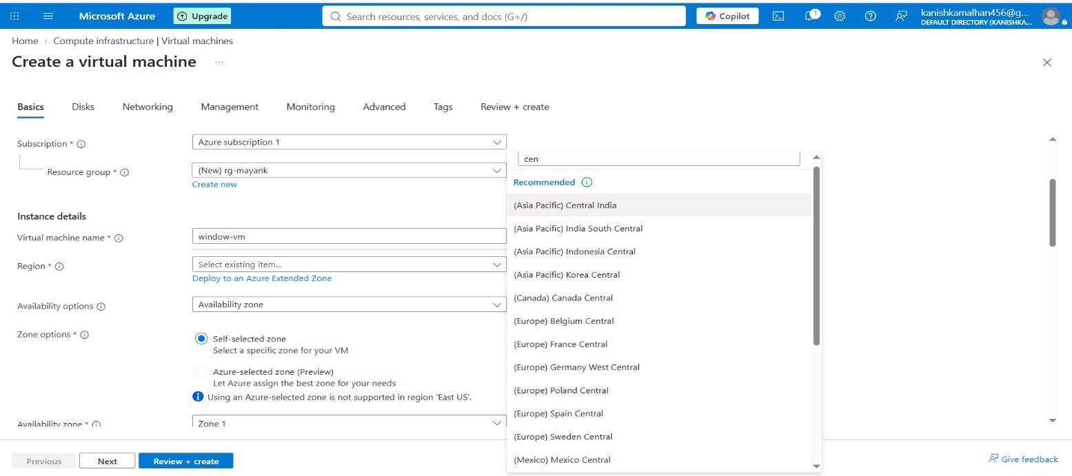

Step 5: Select Operating System Image
Choose the operating system image that will be installed on the virtual machine.
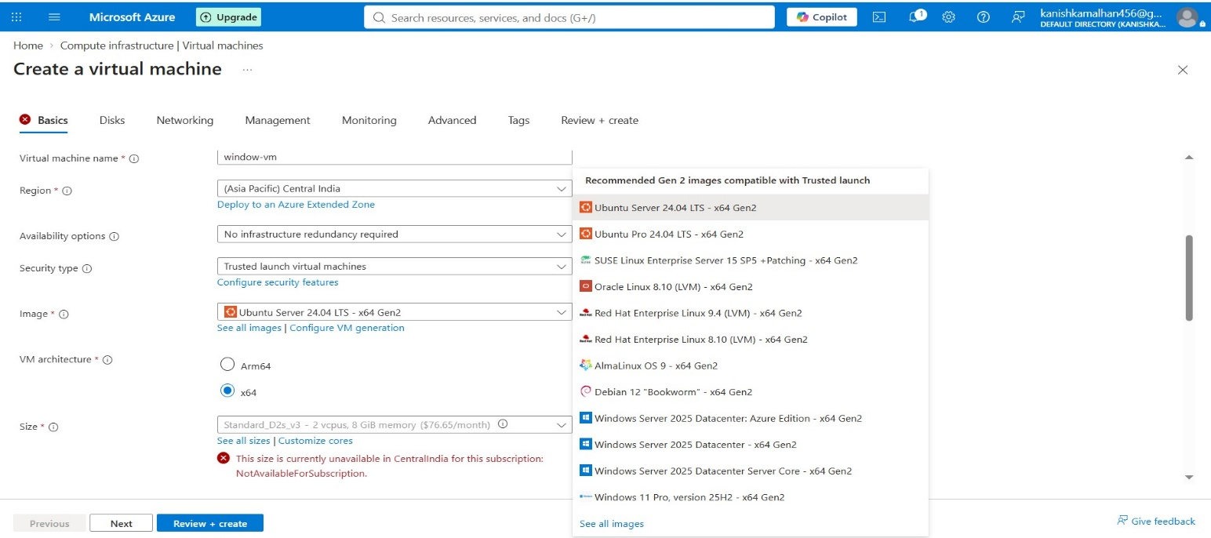

Step 6: Select VM Size
Select Standard_B2s_v2 virtual machine size based on the required CPU and memory resources.
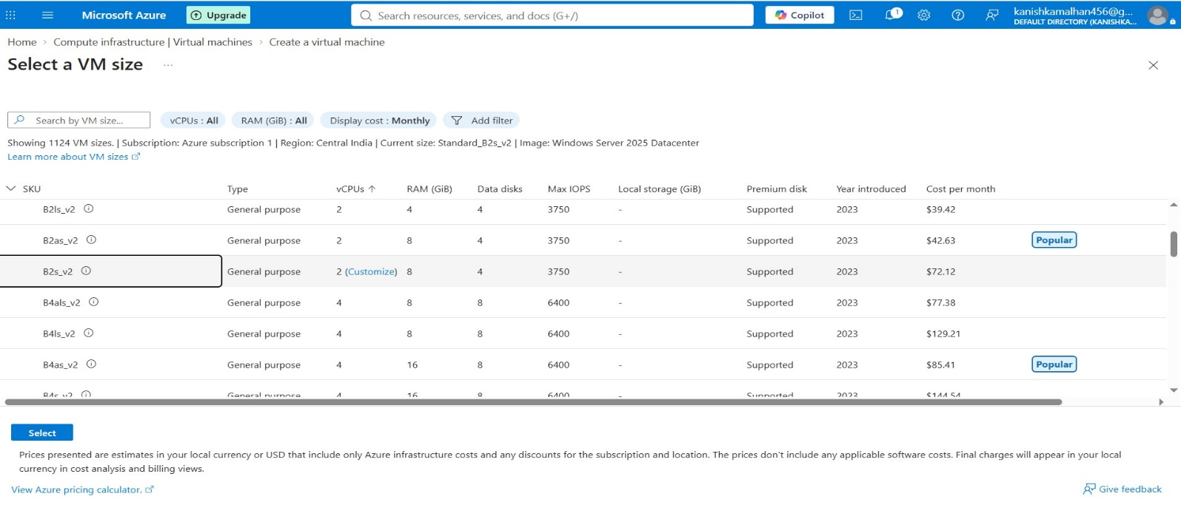

Step 7: Configure RDP Access
Enable RDP (3389) under inbound ports to allow remote access to the Windows virtual machine.
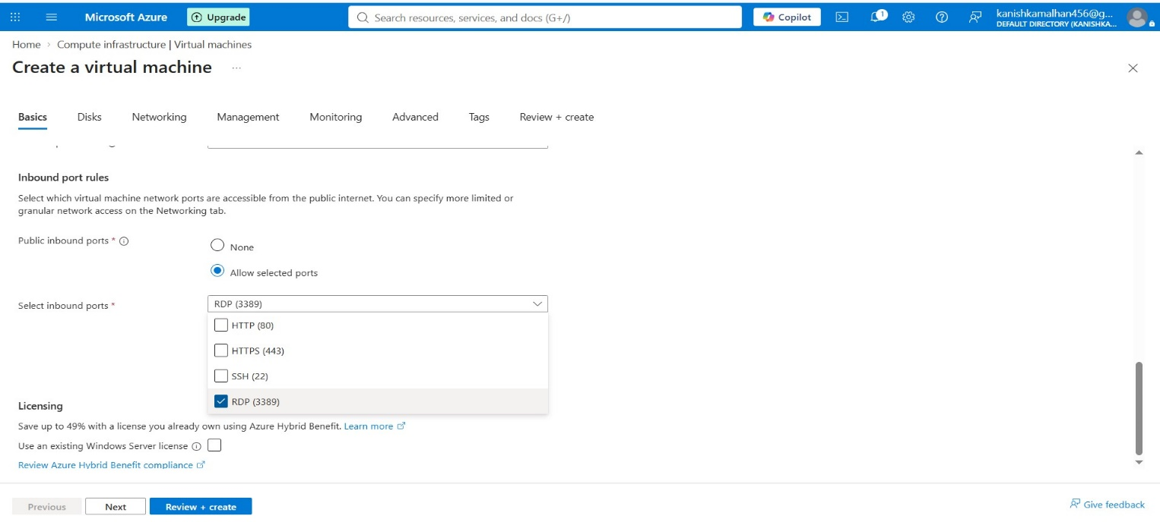

Step 8: Configure Disk Settings
Review and configure OS disk settings. Premium SSD storage provides better performance and reliability.
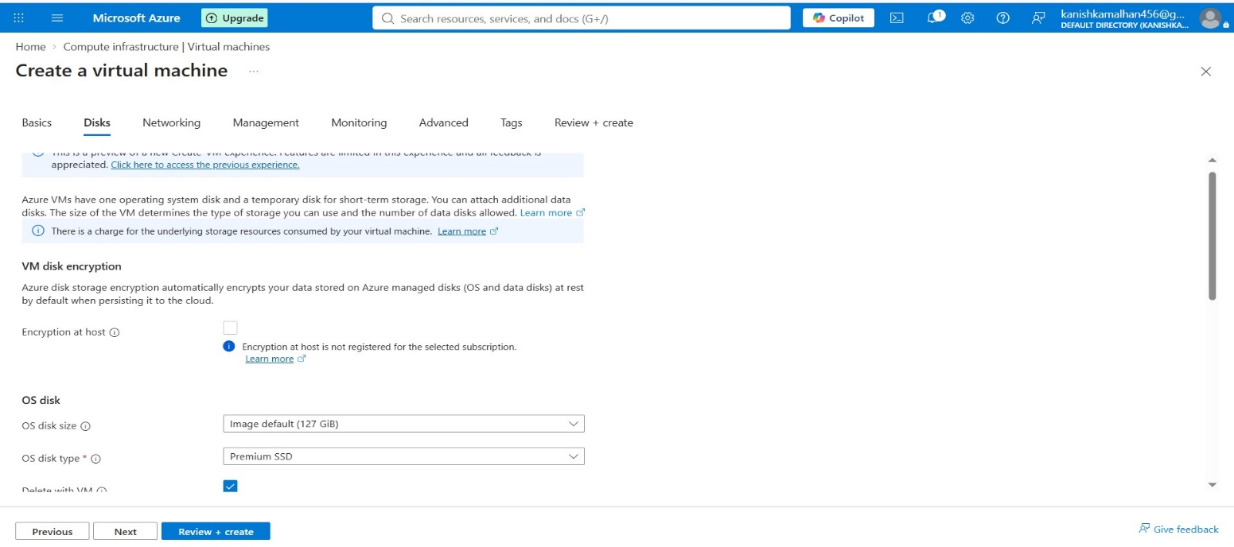

Step 9: Create Virtual Network
Configure a Virtual Network (VNet) to provide network communication for the virtual machine.
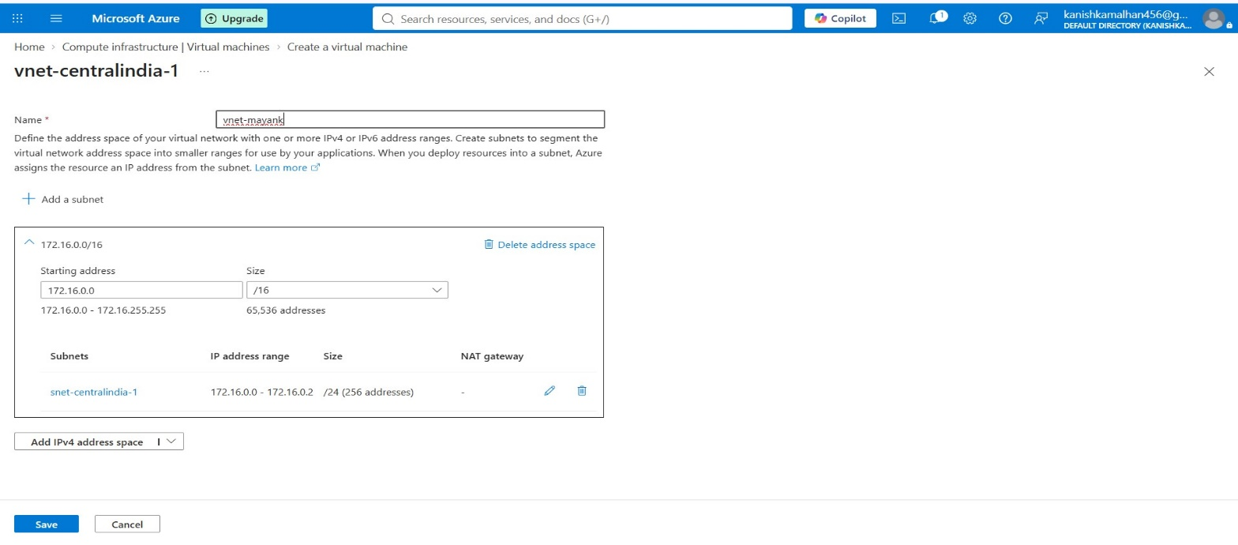

Step 10: Create Subnet
Create a subnet within the Virtual Network to logically separate and organize network resources.
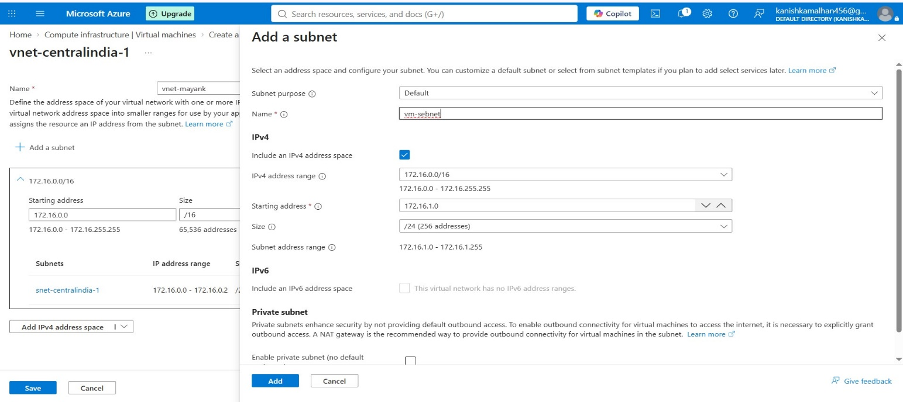

Step 11: Create and Associate Public IP Address
A Public IP address allows the virtual machine to be accessed from the internet. Configure a Public IP, associate it with the VM network interface, and verify NSG settings.
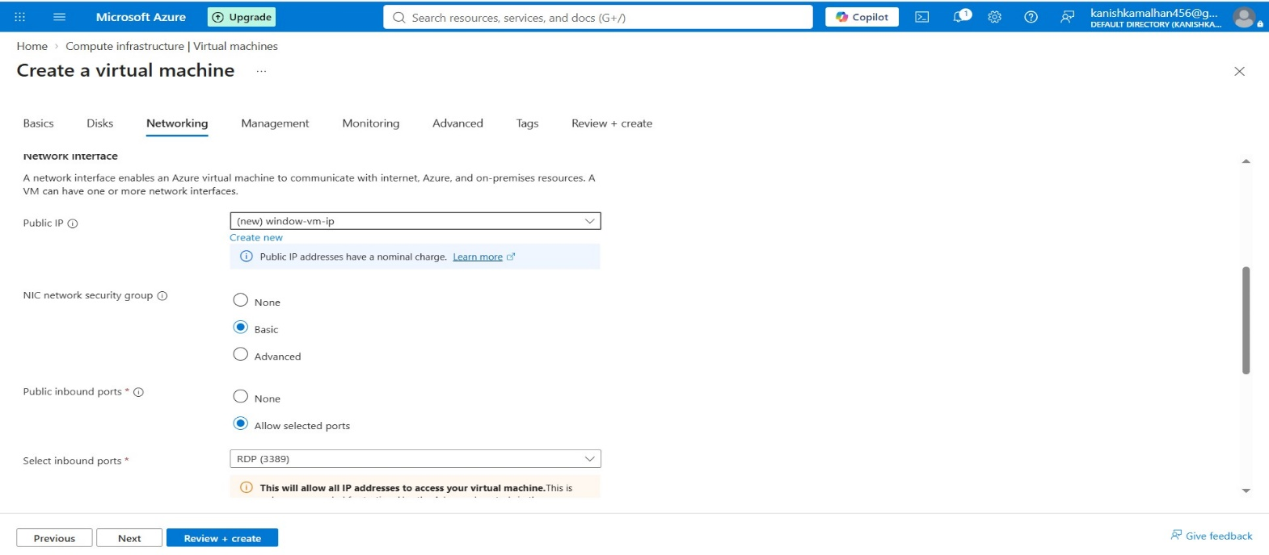

Step 12: Review and Validate Configuration
Review all selected settings and validate the deployment configuration before creating the VM.
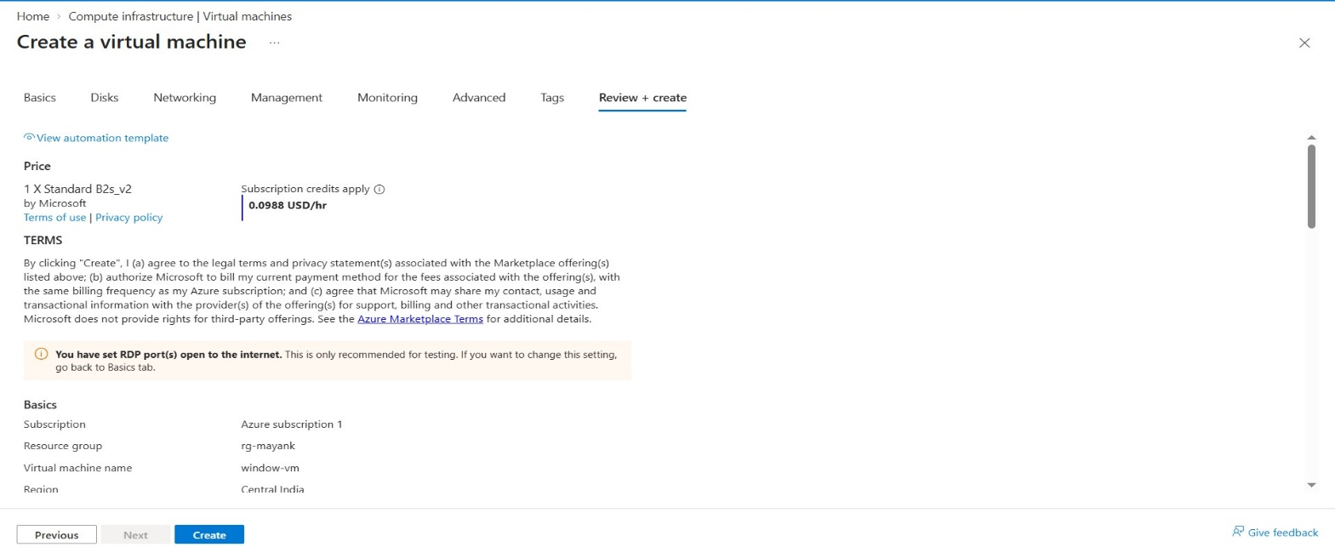

Step 13: Verify Resource Deployment
After successful deployment, verify that all related resources such as VM, Disk, NIC, VNet, NSG, and Public IP have been created.
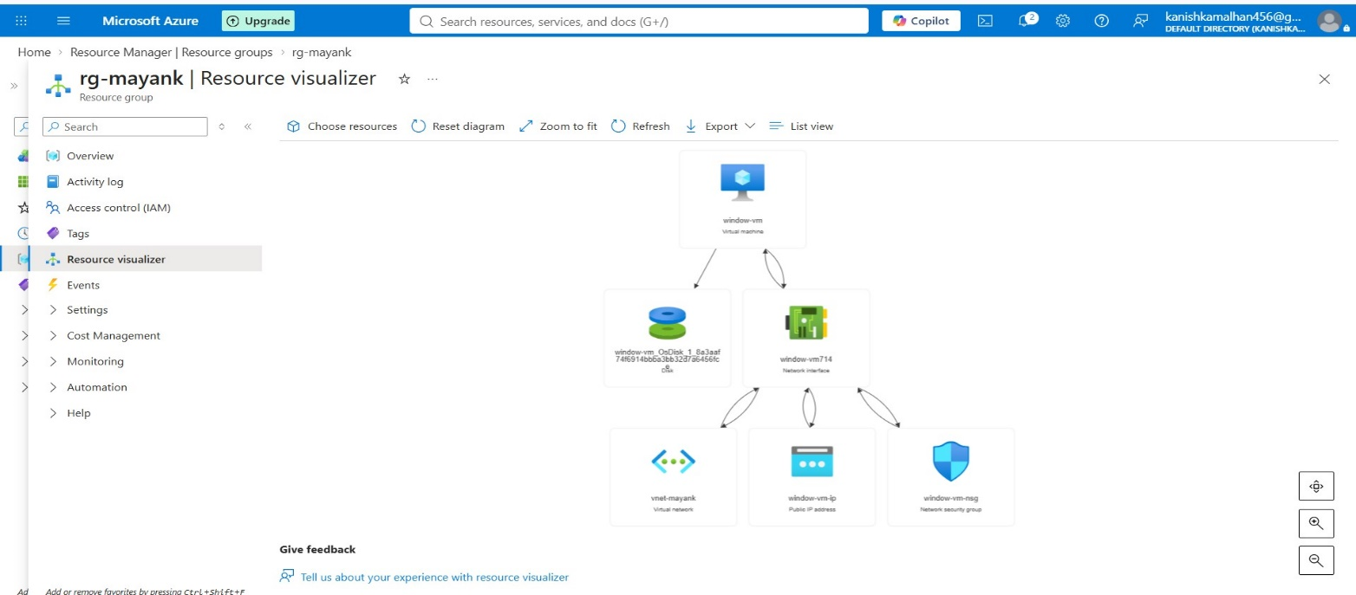

Step 14: Configure RDP Connection
Open the VM Connect page, verify the Public IP address and RDP port, and download the RDP connection file.

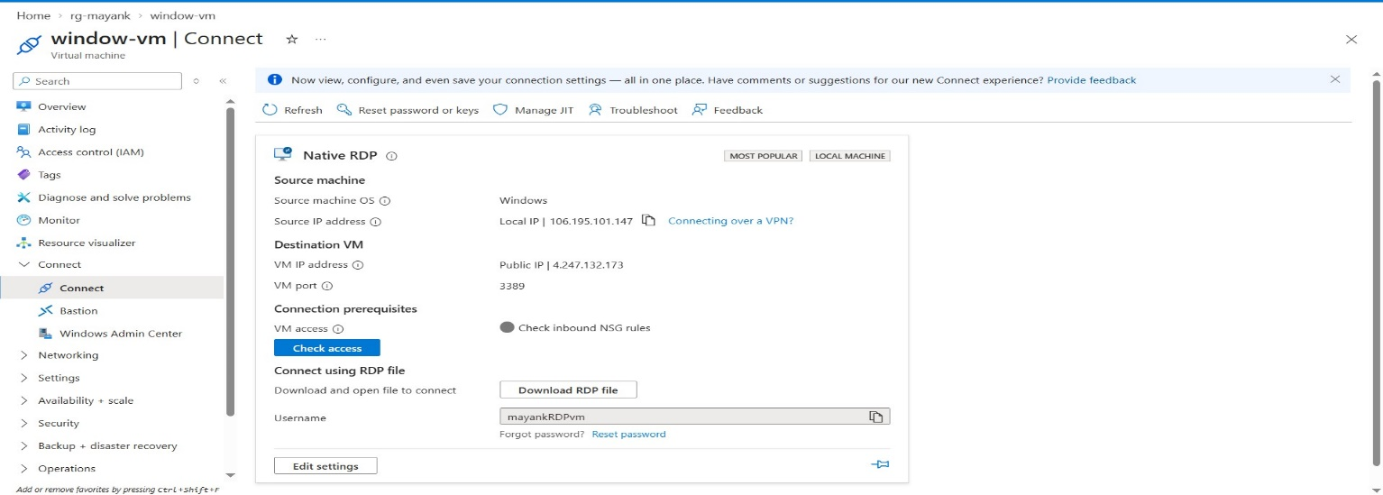📸

Step 15: Authenticate and Connect to VM
Enter the configured username and password to establish the RDP session and access the Windows virtual machine.
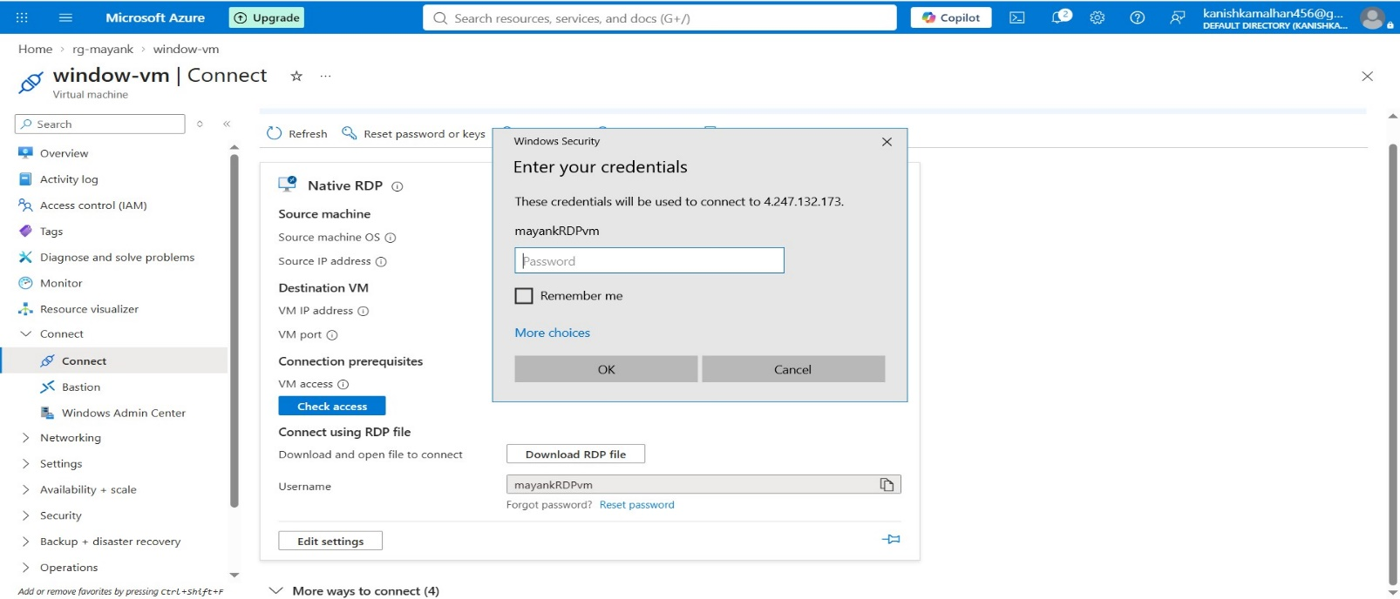

Validation
- Windows VM Created Successfully
- Standard B2s VM Size Selected
- Virtual Network Created
- Subnet Created
- Public IP Created and Associated
- NSG Configured
- RDP Port 3389 Enabled
- RDP Connection Successful

Conclusion
A Windows Virtual Machine was successfully deployed in Azure using the Standard B2s size. A Virtual Network, Subnet, Public IP Address, and Network Security Group were configured. The Public IP was associated with the VM, and a successful RDP connection was established for remote administration.

